User Manual

WEBEVAL v1.0.1

Software Developer: *Timothy Tripp II*

Project Supervisor: *Prof. Devon Simmonds*

Project Client: *Prof. Jeeyae Choi*

WebEval Description:

A Web Application which allows users to record their answers to specific questions on the web application.

How to Access:

*Compatible with Chrome, and Firefox*

*Not Compatible with internet explorer.*

*Must allow WebEval access to your microphone in order to record.*

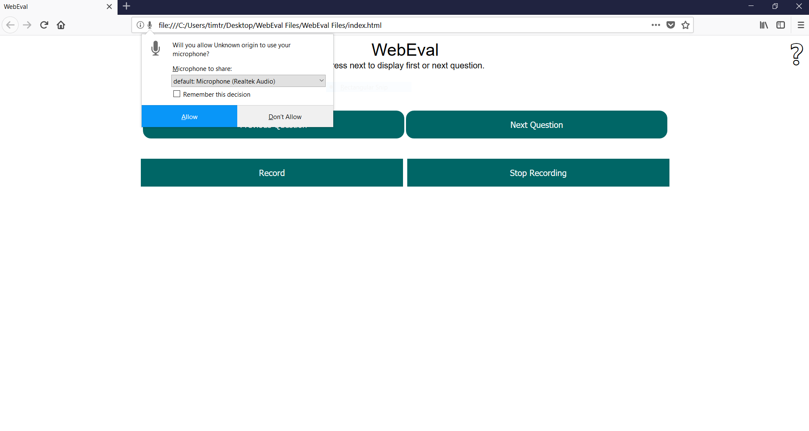

How to Change Question:

*Navigate questions by pressing 'Next Question' or 'Previous Question'*

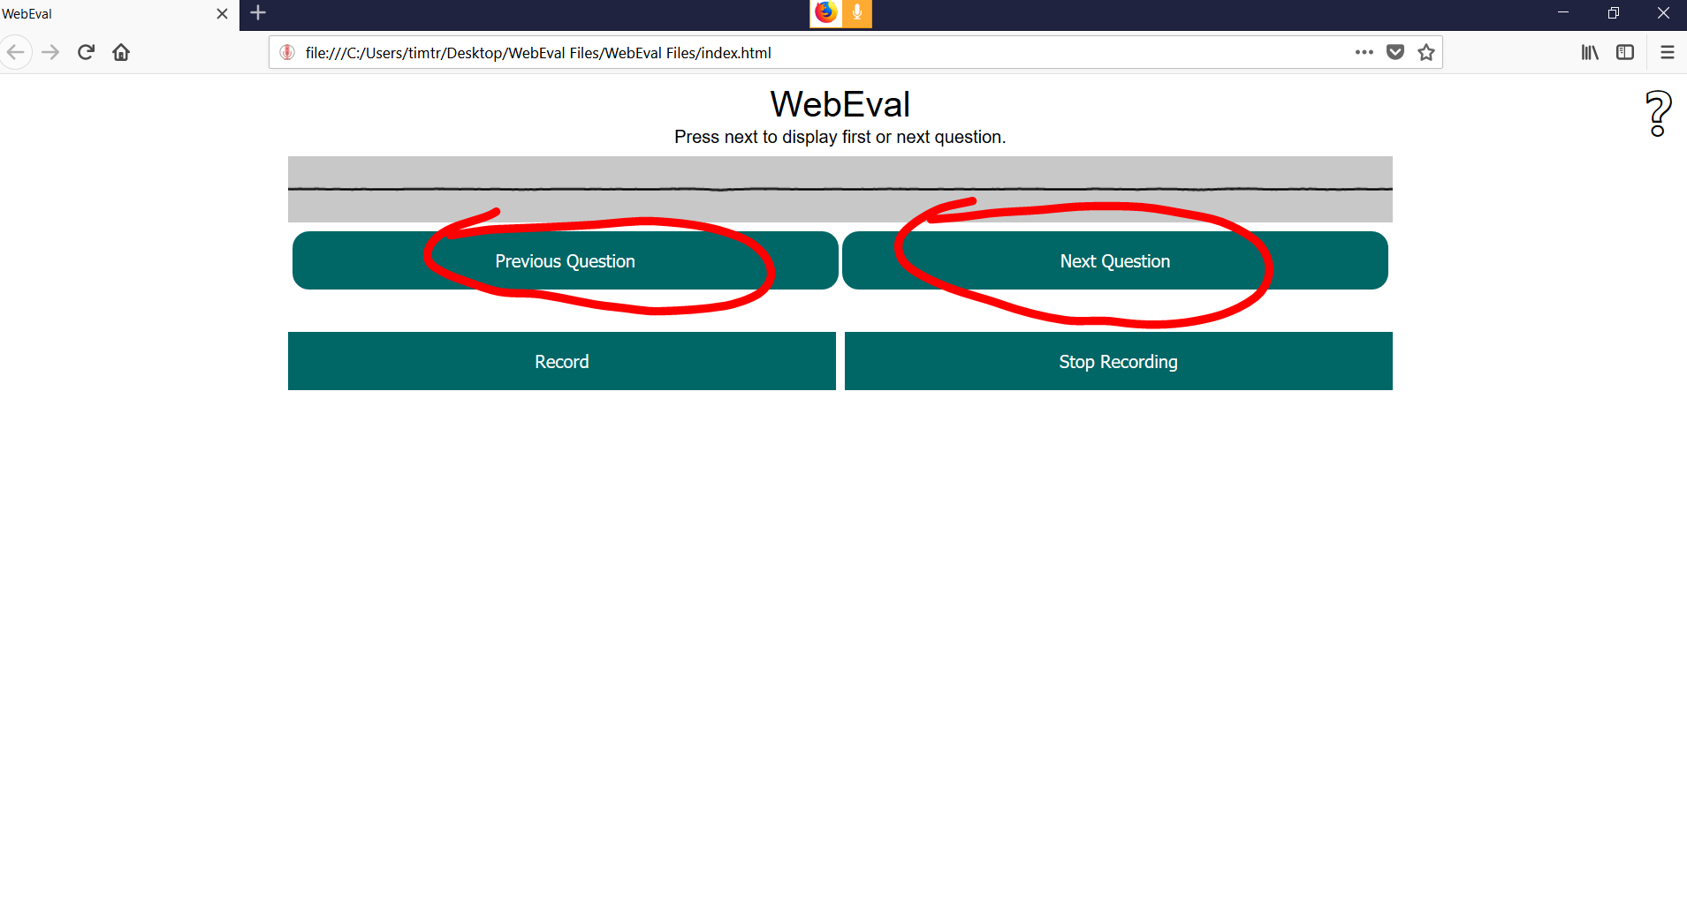

How to Record:

*Begin your recording by pressing 'Record'*

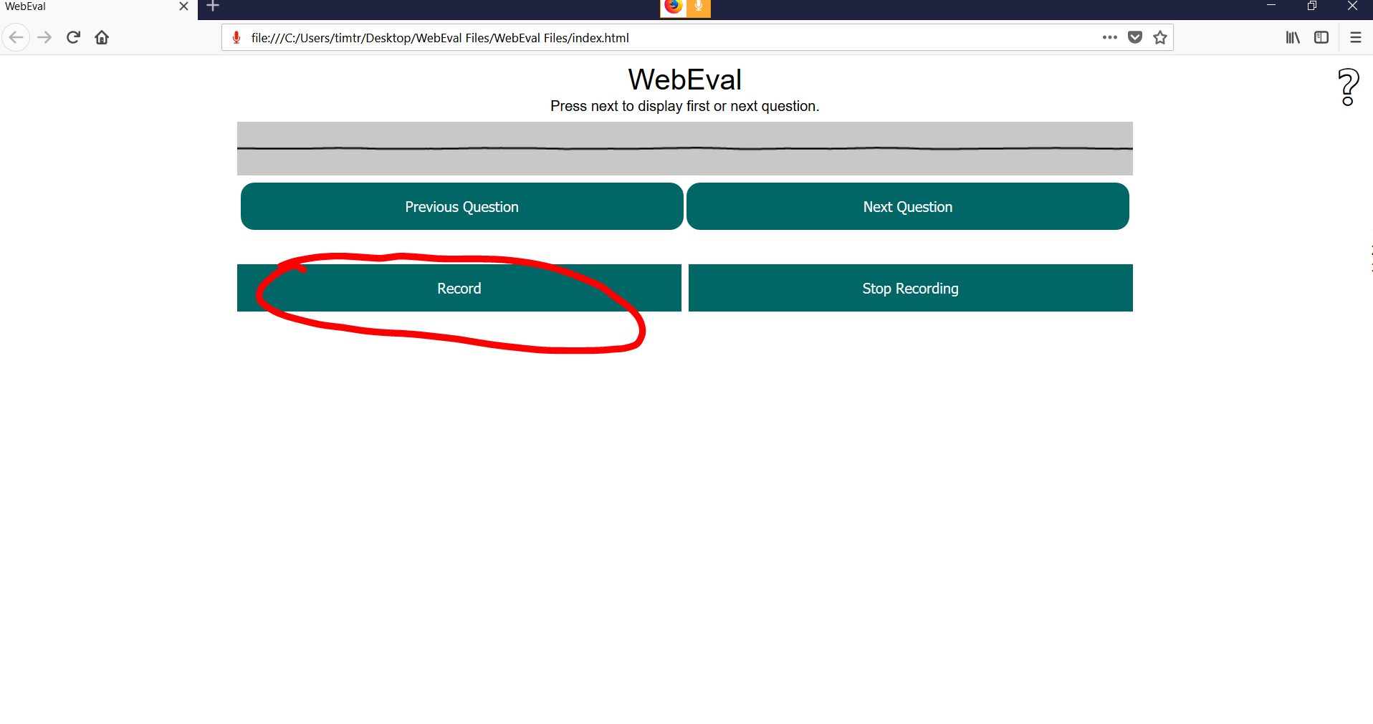

How to Stop Recording:

*Stop your recording by pressing 'Stop Recording'*

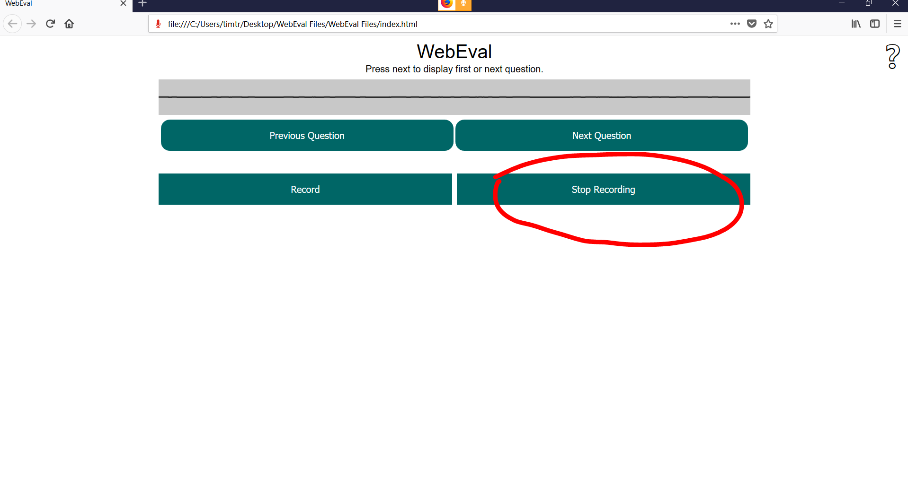

How to Name Recording:

*Once you have pressed 'Stop Recording' a pop up will show up on the screen defaulting to 'my unnamed clip' can be changed to whatever the user wishes to name it.*

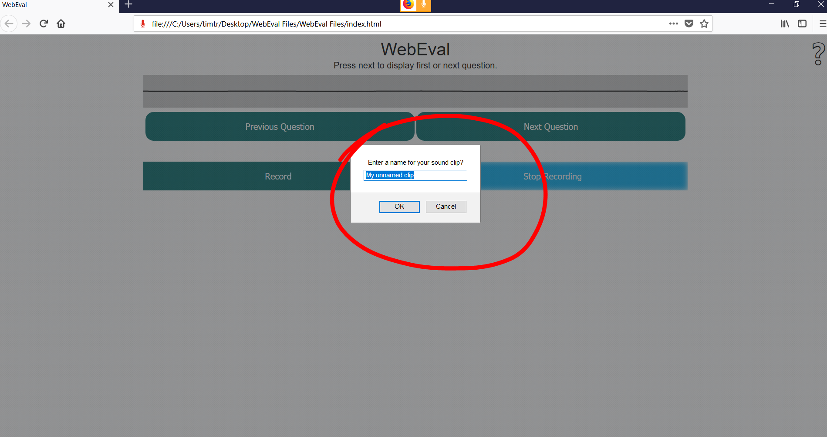

How to Save Recording:

*Once you finished naming the recording and pressed 'OK'. Right click on the name of the recording a click 'save as' to save locally on your computer.*

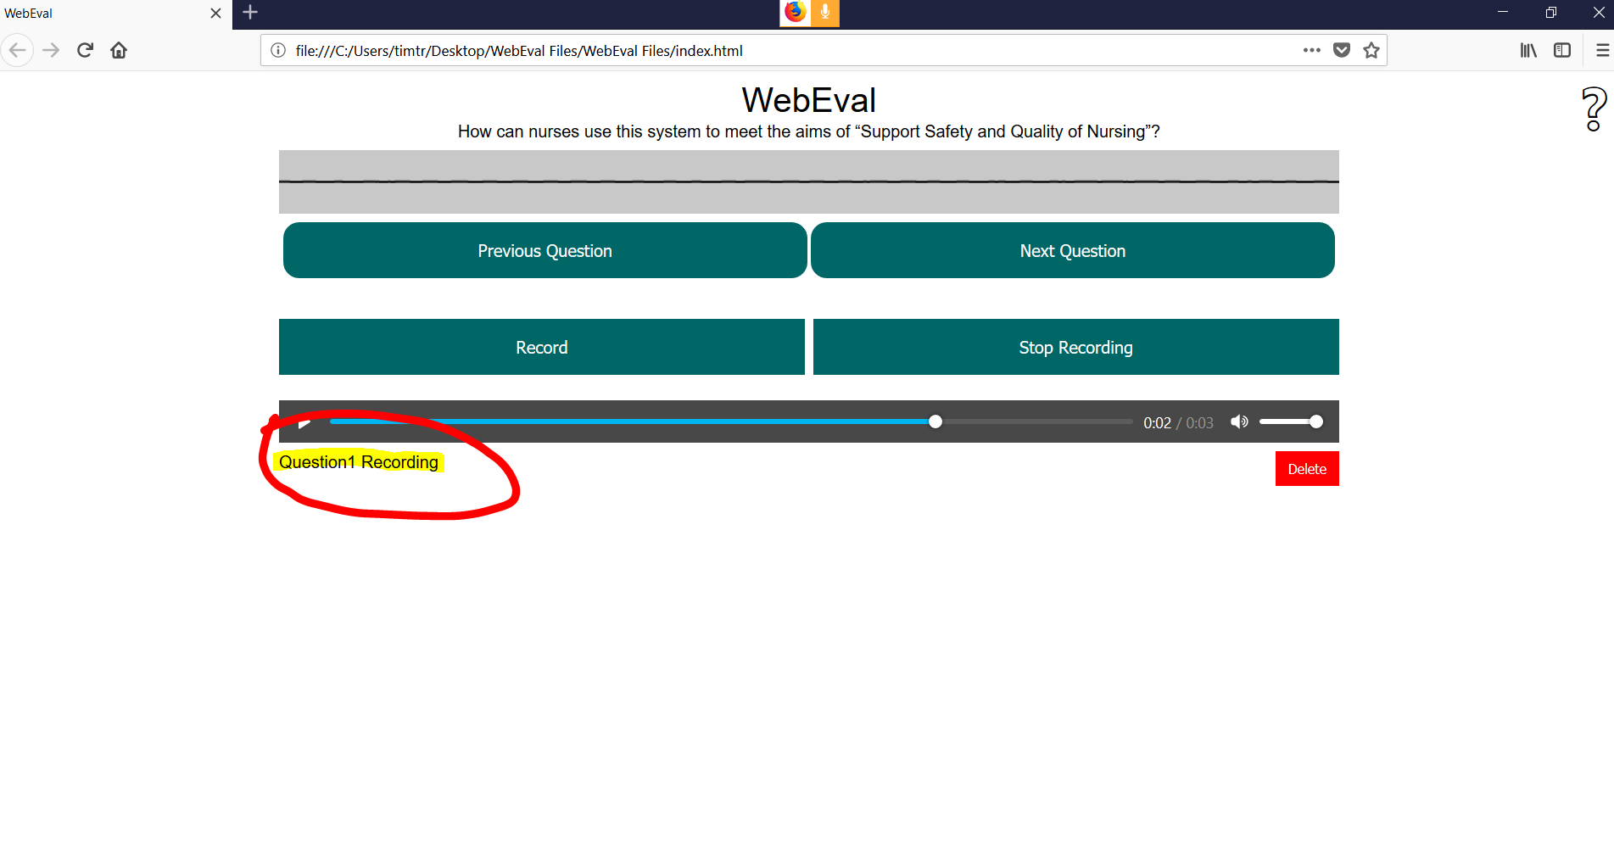

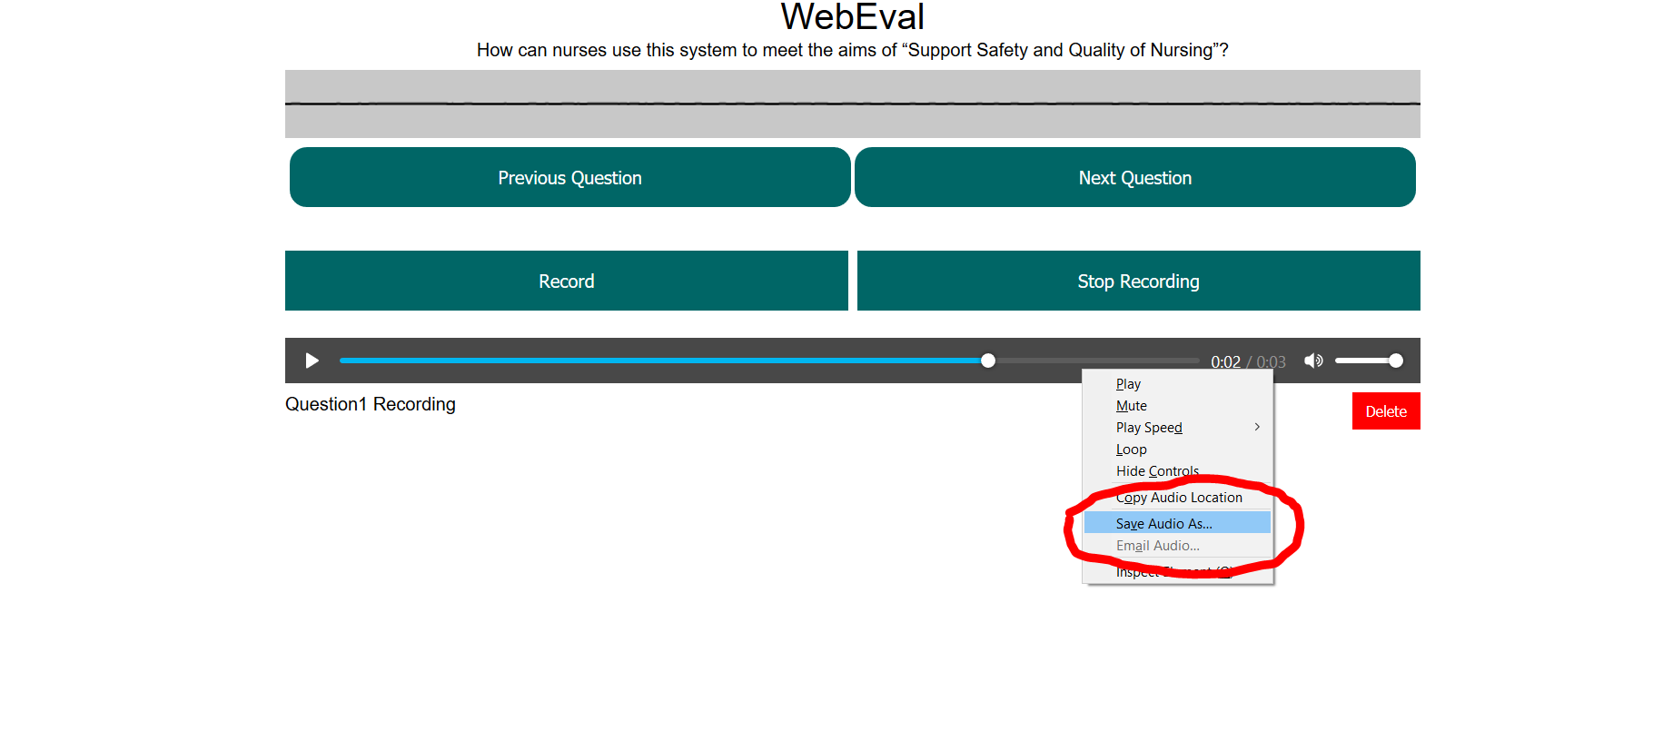

How to Delete Recording:

*Once the recording has been stopped press the 'Delete' button on the right side of the screen.*

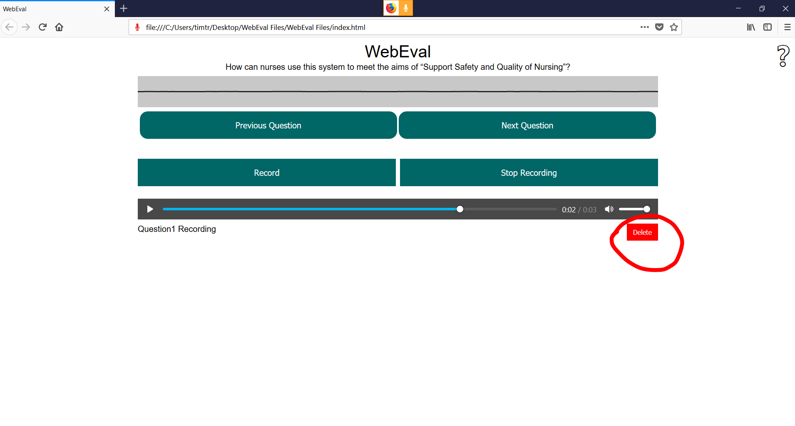

How to Find Help:

*To find basic instructions to navigate the WebEval main page press the '?' On the top right of the screen.*

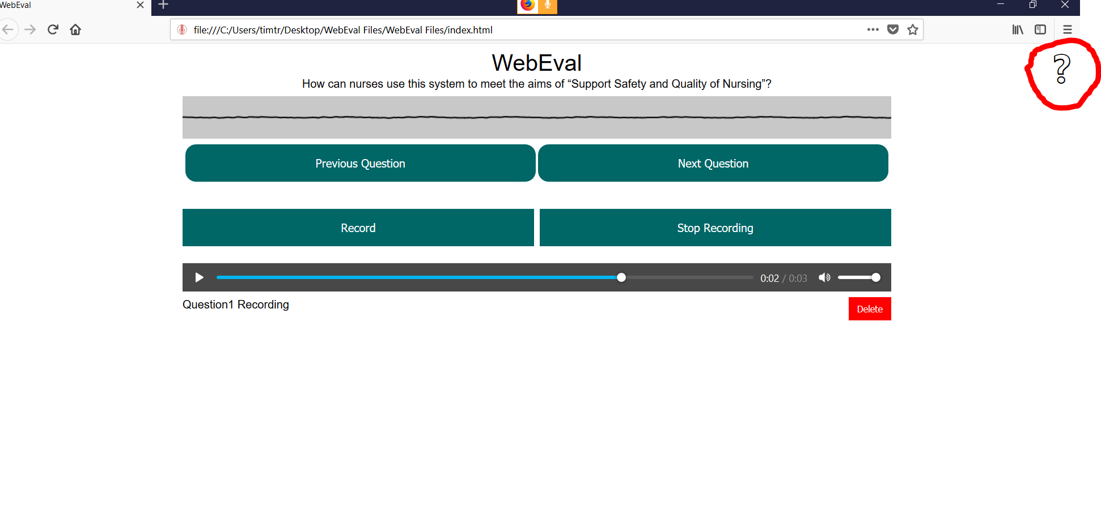

Admin Helpful Info:

How to add or change questions on WebEval:

*Currently the only way to change questions is to adjust the list that is inside the index.html file inside WebEval source code.*



*Must have access to source code. Currently working on way for admin to adjust question set by using main page.*

Sound Files Saved as: *.OOG files*